How to connect MongoDB with Node application:

**What is Mongoose?**

**Mongoose** is an Object Data Modeling (ODM) library for MongoDB and Node.js. It provides a straightforward, schema-based solution to model your application data. With Mongoose, you can define schemas for your data, validate input, and interact with MongoDB using a clean and organized API.

**Key Features of Mongoose**

1. **Schema Definition**: Allows you to define the structure of your MongoDB documents.
2. **Data Validation**: Ensures data conforms to your schema before saving.
3. **Middleware**: Enables hooks to perform operations before or after database actions (e.g., saving data).
4. **Query Building**: Provides an intuitive syntax for querying MongoDB.
5. **Relationships**: Allows referencing documents between collections using populate and other features.

Step 1:

To connect mongoDb with node application we need mongoose package using below command.

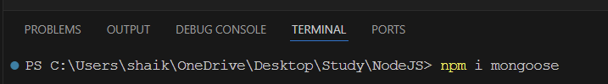

Step 2: create new folder in project named ‘util’, inside util folder create file dbConnection.js. in this dbConnection.js file and export function from this file and import into app.js to call function we will write code for connecting our application with Mongodb database using mongoose package.

Get connection string from MongoDB atlas as shown below.

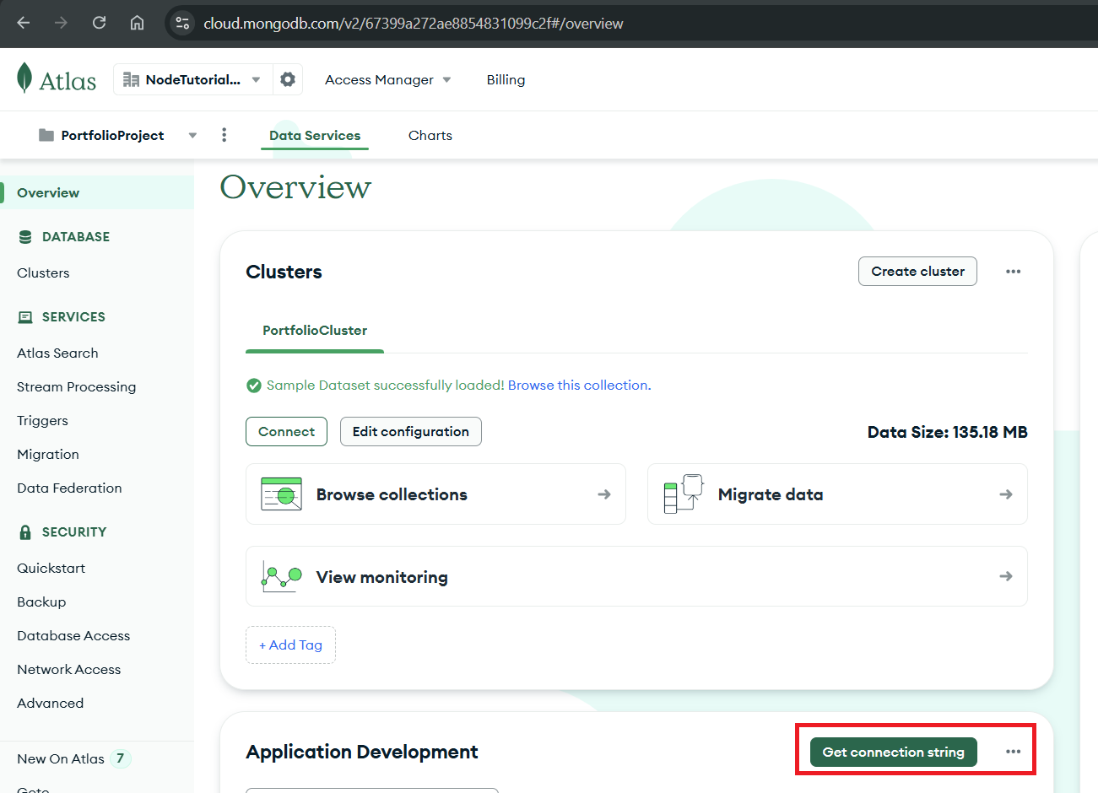

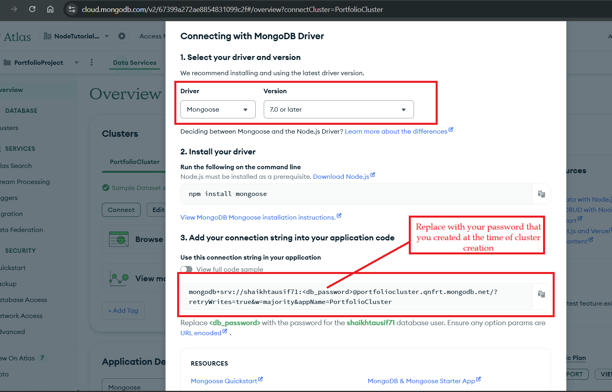

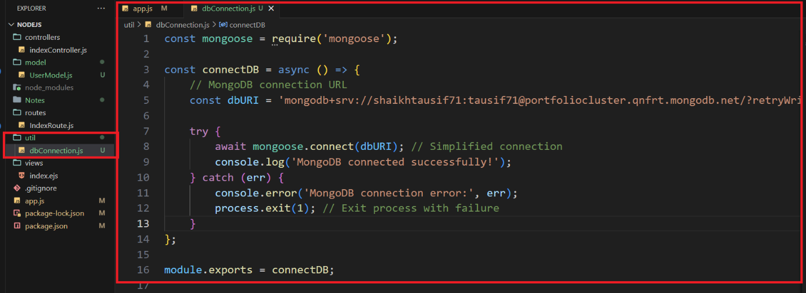

Step 3:

Open app.js folder import dbConnection.js file and call function as shown below.

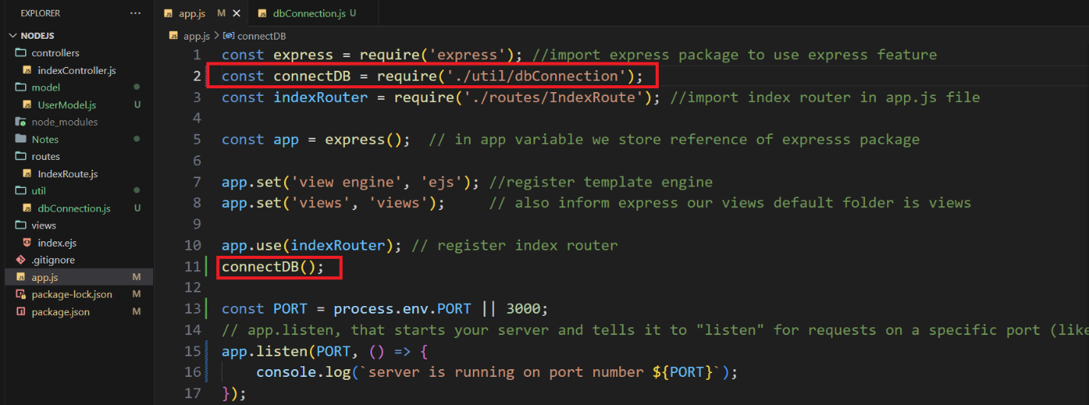

Now run project using npm start command if you see ‘MongoDB connected successfully!’ Means your database is connected otherwise you will get an error.